Постановка задачи

Задание (Вариант 4).Иерархия графических компонентов. Имеется набор компонентов: окно, надпись, список, кнопка, панель, линия. Компоненты окно и панель могут содержать другие компоненты. Компоненты могут быть видимы или скрыты, компоненты можно перемещать в пределах контейнера. Требуется отобразить иерархию компонентов и навигацию по ней в виде дерева.

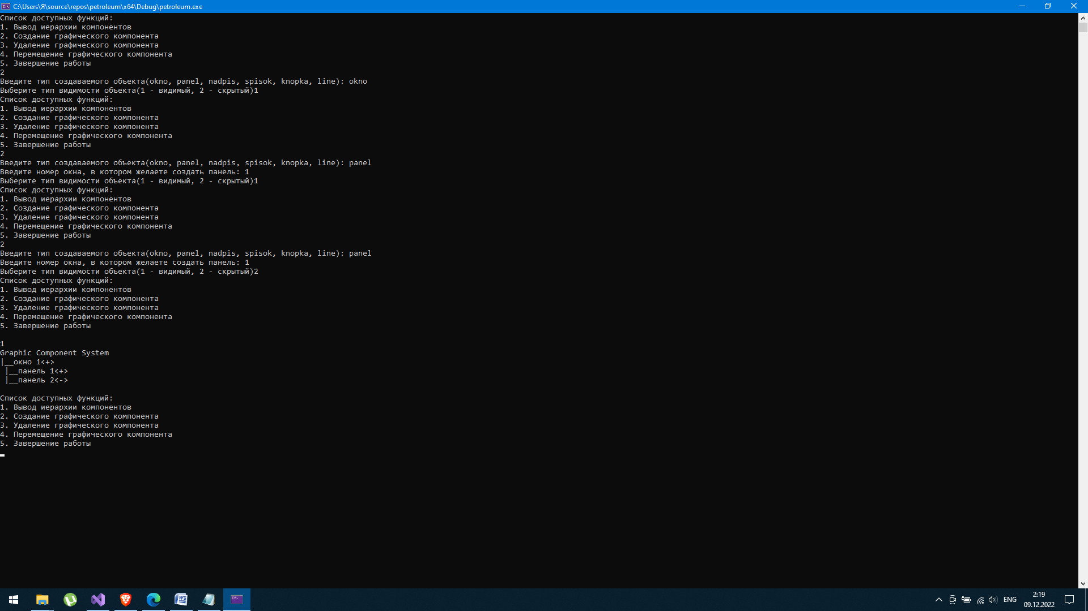

Рисунок 1 – Создание нескольких компонентов разного типа

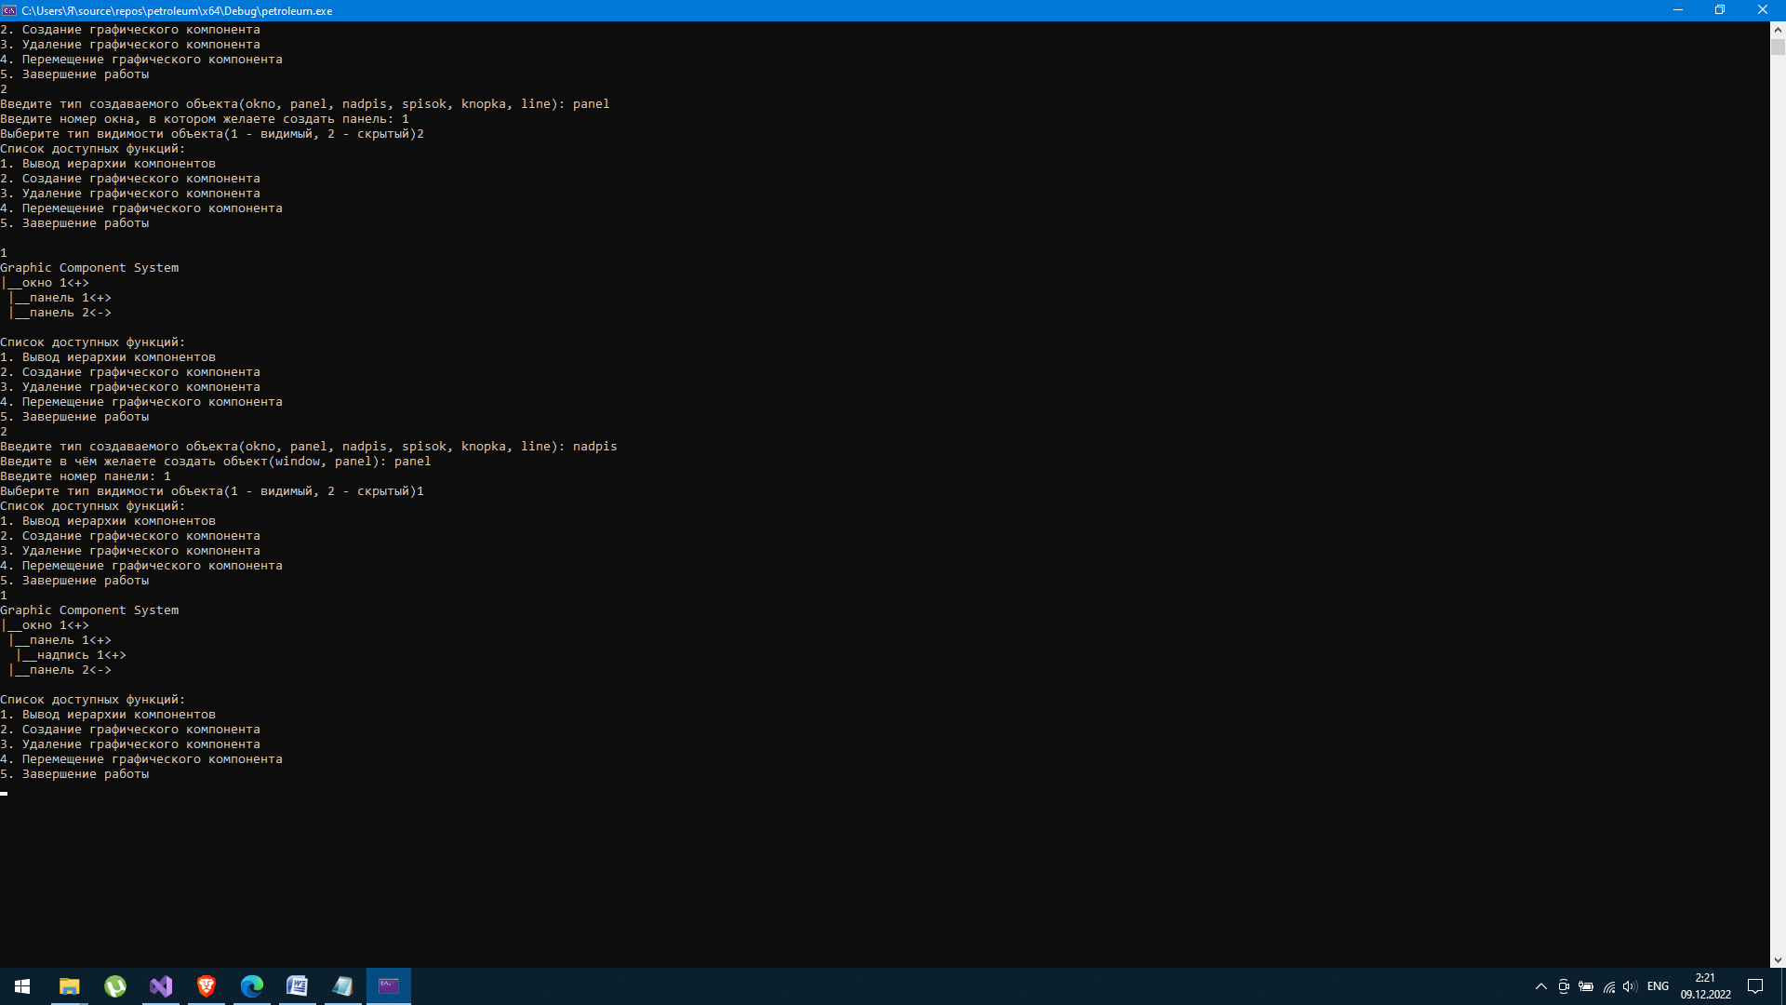

Рисунок 2 – Вывод иерархии после создания нескольких компонентов

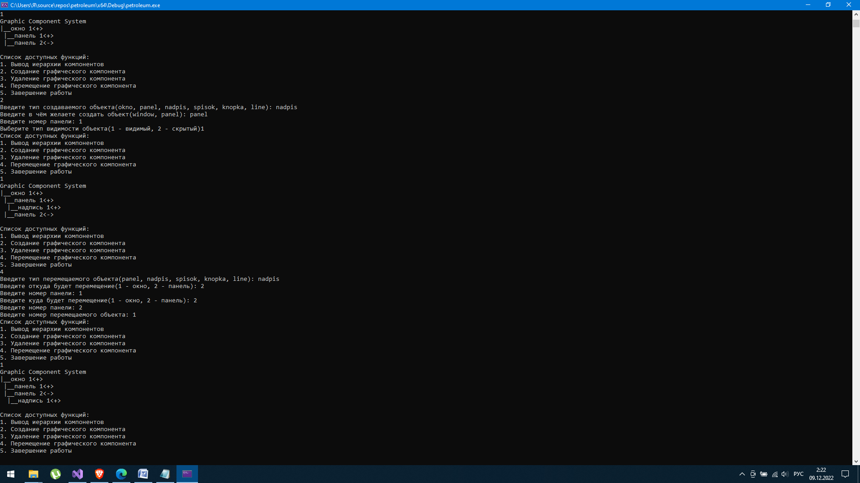

Рисунок 3 – Перемещение графического компонента надпись из первой панели во вторую

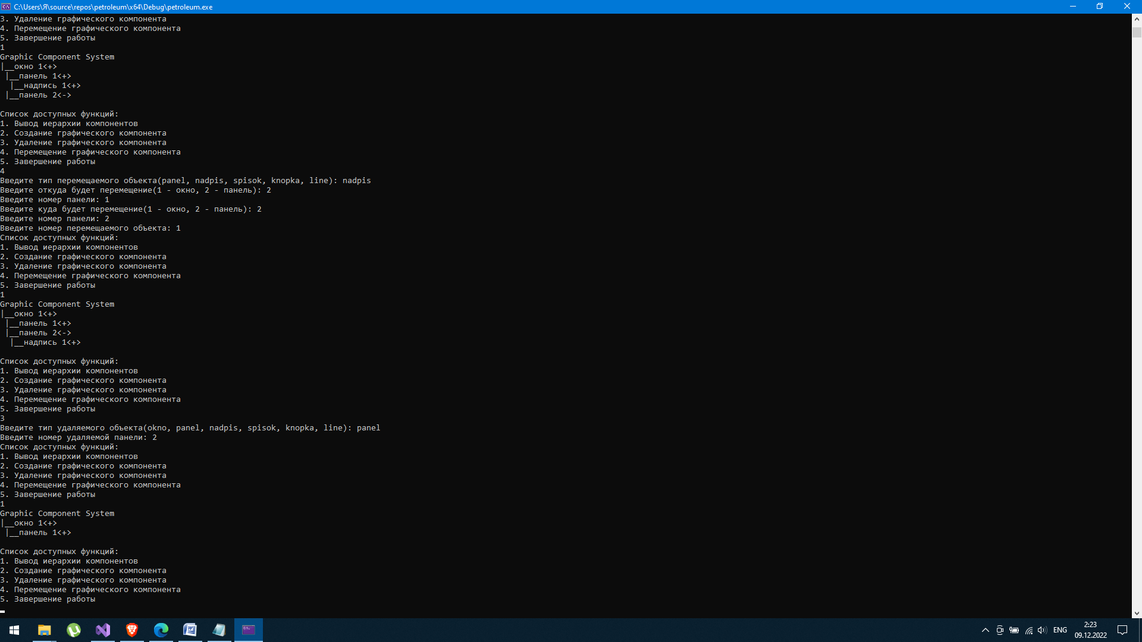

Рисунок 4 – Удаление второй панели с вложенной в неё надписью

Приложение

Полный текст программы:

#include <iostream>  
#include <string>  
using namespace std;  
class father_object  
{  
protected:  
 string name;  
 string visibl;  
 int first_numb;  
 int numb;  
 int second_numb;  
 int kol_ins;  
 int kol_list;  
 int kol_buttom;  
 int kol_panel;  
 int kol_line;  
public:  
 string get_name() { return name; };  
 string get_visibl() { return visibl; };  
 int get_first_numb() { return first_numb; };  
 int get_second_numb() { return second_numb; };  
 int get_kol_ins() { return kol_ins; };  
 int get_kol_list() { return kol_list; };  
 int get_kol_buttom() { return kol_buttom; };  
 int get_kol_panel() { return kol_panel; };  
 int get_kol_line() { return kol_line; };  
 int get_numb() { return numb; };  
 int up_kol_ins() { return (kol_ins = kol_ins + 1); };  
 int up_kol_list() { return (kol_list = kol_list + 1); };  
 int up_kol_buttom() { return (kol_buttom = kol_buttom + 1); };  
 int up_kol_panel() { return (kol_panel = kol_panel + 1); };  
 int up_kol_line() { return (kol_line = kol_line + 1); };  
 int down_kol_ins() { return (kol_ins = kol_ins - 1); };  
 int down_kol_list() { return (kol_list = kol_list - 1); };  
 int down_kol_buttom() { return (kol_buttom = kol_buttom - 1); };  
 int down_kol_panel() { return (kol_panel = kol_panel - 1); };  
 int down_kol_line() { return (kol_line = kol_line - 1); };  
};  
class okno : public father_object// создаётся независимо от всех, остальные к нему делают привязку  
{  
public:  
 okno()  
 {  
 kol_ins = 0;  
 kol_list = 0;  
 kol_buttom = 0;  
 kol_panel = 0;  
 kol_line = 0;  
 }  
 void create(okno*& win, int& N_win, int& numb_obj, int& sys_numb)  
 {  
 int new_N = N_win + 1;  
 okno* new_win = new okno[new_N];  
 for (int i = 0; i < N_win; i++)  
 {  
 new_win[i] = win[i];  
 }  
 new_win[N_win].name = "окно " + to_string(numb_obj);  
 new_win[N_win].numb = numb_obj;  
 new_win[N_win].second_numb = sys_numb;  
 cout << "Выберите тип видимости объекта(1 - видимый, 2 - скрытый)";  
 int visibl;  
 cin >> visibl;  
 if (visibl == 1)  
 new_win[N_win].visibl = "<+>";  
 else if (visibl == 2)  
 new_win[N_win].visibl = "<->";  
 delete[] win;  
 win = new_win;  
 N_win = new_N;  
 }  
};  
class panel : public father_object  
{  
public:  
 panel()  
 {  
 kol_ins = 0;  
 kol_list = 0;  
 kol_buttom = 0;  
 kol_line = 0;  
 }  
 void create(okno*& win, panel*& pan, int& N_win, int& N_pan, int& numb_obj, int& sys_numb)  
 {  
 string name_father;  
 int sch;  
 int new_N = N_pan + 1;  
 panel* new_pan = new panel[new_N];  
 for (int i = 0; i < N_pan; i++)  
 {  
 new_pan[i] = pan[i];  
 }  
 cout << "Введите номер окна, в котором желаете создать панель: ";  
 cin >> sch;  
 for (int i = 0; i < N_win; i++)  
 {  
 if (win[i].get_numb() == sch)  
 {  
 new_pan[N_pan].first_numb = win[i].get_second_numb();  
 new_pan[N_pan].name = "панель " + to_string(numb_obj);  
 new_pan[N_pan].numb = numb_obj;  
 new_pan[N_pan].second_numb = sys_numb;  
 win[i].up_kol_panel();  
 break;  
 }  
 }  
 cout << "Выберите тип видимости объекта(1 - видимый, 2 - скрытый)";  
 int visibl;  
 cin >> visibl;  
 if (visibl == 1)  
 new_pan[N_pan].visibl = "<+>";  
 else if (visibl == 2)  
 new_pan[N_pan].visibl = "<->";  
 delete[] pan;  
 pan = new_pan;  
 N_pan = new_N;  
 }  
 void move_pan(okno*& win, panel*& pan, int& N_win, int& N_pan)  
 {  
 int sch_old, sch_new, old_numb, new_numb, numb_obj, new_ind_obj, numb_old, numb_new;  
  
 cout << "Введите номер окна, откуда будет совершено перемещение: ";  
 cin >> numb_old;  
 for (int i = 0; i < N_win; i++)  
 {  
 if (win[i].get_numb() == numb_old)  
 {  
 win[i].down_kol_panel();  
 break;  
 }  
 }  
 cout << "Введите номер окна, в которе будет совершено перемещение: ";  
 cin >> numb_new;  
 for (int i = 0; i < N_win; i++)  
 {  
 if (win[i].get_numb() == numb_new)  
 {  
 new_ind_obj = win[i].get_second_numb();  
 win[i].up_kol_panel();  
 break;  
 }  
 }  
 cout << "Введите номер перемещаемого объекта: ";  
 cin >> numb_obj;  
 for (int i = 0; i < N_pan; i++)  
 {  
 if (pan[i].get_numb() == numb_obj)  
 {  
 pan[i].first_numb = new_ind_obj;  
 break;  
 }  
 }  
 }  
};  
class object  
{  
protected:  
 string name;  
 int numb;  
 int first_numb;  
 int second_numb;  
 string visibl;  
public:  
 string get_name() { return name; };  
 int get_first_numb() { return first_numb; };  
 int get_second_numb() { return second_numb; };  
 int get_numb() { return numb; };  
 string get_visibl() { return visibl; };  
 template <typename T>  
 void create(okno*& win, panel*& panel, T*& obj, int& N_win, int& N_panel, int& N_obj, int& system_numb, int& numb_obj, int type)  
 {  
 string name_father;  
 string sch;  
 int numb;  
 int new_N = N_obj + 1;  
 cout << "Введите в чём желаете создать объект(window, panel): ";  
 getline(cin, sch);  
 T* new_obj = new T[new_N];  
 for (int i = 0; i < N_obj; i++)  
 {  
 new_obj[i] = obj[i];  
 }  
 while (true)  
 {  
 if (sch == "window")  
 {  
 cout << "Введите номер окна: ";  
 cin >> numb;  
 for (int i = 0; i < N_win; i++)  
 {  
 if (win[i].get_numb() == numb)  
 {  
 new_obj[N_obj].first_numb = win[i].get_second_numb();  
 new_obj[N_obj].second_numb = system_numb;  
 if (type == 1)  
 new_obj[N_obj].name = "надпись " + to_string(numb_obj);  
 if (type == 2)  
 new_obj[N_obj].name = "список " + to_string(numb_obj);  
 if (type == 3)  
 new_obj[N_obj].name = "кнопка " + to_string(numb_obj);  
 if (type == 4)  
 new_obj[N_obj].name = "линия " + to_string(numb_obj);  
 new_obj[N_obj].numb = numb_obj;  
 if (type == 1)  
 win[i].up_kol_ins();  
 if (type == 2)  
 win[i].up_kol_list();  
 if (type == 3)  
 win[i].up_kol_buttom();  
 if (type == 4)  
 win[i].up_kol_line();  
 break;  
 }  
 }  
 break;  
 }  
 else if (sch == "panel")  
 {  
 cout << "Введите номер панели: ";  
 cin >> numb;  
 for (int i = 0; i < N_panel; i++)  
 {  
 if (panel[i].get_numb() == numb)  
 {  
 new_obj[N_obj].first_numb = panel[i].get_second_numb();  
 new_obj[N_obj].second_numb = system_numb;  
 new_obj[N_obj].name = "надпись " + to_string(numb_obj);  
 new_obj[N_obj].numb = numb_obj;  
 if (type == 1)  
 panel[i].up_kol_ins();  
 if (type == 2)  
 panel[i].up_kol_list();  
 if (type == 3)  
 panel[i].up_kol_buttom();  
 if (type == 4)  
 panel[i].up_kol_line();  
 break;  
 }  
 }  
 break;  
 }  
 else  
 {  
 cout << "такого варианта нет!" << endl;  
 }  
 }  
 cout << "Выберите тип видимости объекта(1 - видимый, 2 - скрытый)";  
 int visibl;  
 cin >> visibl;  
 if (visibl == 1)  
 new_obj[N_obj].visibl = "<+>";  
 else if (visibl == 2)  
 new_obj[N_obj].visibl = "<->";  
 delete[] obj;  
 obj = new_obj;  
 N_obj = new_N;  
 }  
 template <typename T>  
 void del(okno*& win, panel*& pan, T*& obj, int& N_win, int& N_obj, int& N_pan, int numb_del, int type)  
 {  
 int new_N = N_obj - 1;  
 T* new_obj = new T[new_N];  
 int numb_delete;  
 for (int i = 0; i < N_obj; i++)  
 {  
 if (obj[i].get_numb() == numb_del)  
 {  
 numb_delete = i;  
 break;  
 }  
 }  
 for (int i = 0; i < N_win; i++)  
 {  
 if (obj[numb_delete].get_first_numb() == win[i].get_second_numb())  
 {  
 if (type == 1)  
 win[i].down_kol_ins();  
 if (type == 2)  
 win[i].down_kol_list();  
 if (type == 3)  
 win[i].down_kol_buttom();  
 if (type == 4)  
 win[i].down_kol_line();  
 break;  
 }  
 }  
 for (int i = 0; i < N_pan; i++)  
 {  
 if (obj[numb_delete].get_first_numb() == pan[i].get_second_numb())  
 {  
 if (type == 1)  
 pan[i].down_kol_ins();  
 if (type == 2)  
 pan[i].down_kol_list();  
 if (type == 3)  
 pan[i].down_kol_buttom();  
 if (type == 4)  
 pan[i].down_kol_line();  
 break;  
 }  
 }  
 int j = 0;  
 for (int i = 0; i < N_obj; i++)  
 {  
 if (i != numb_delete)  
 {  
 new_obj[j] = obj[i];  
 j++;  
 }  
 }  
 delete[] obj;  
 obj = new_obj;  
 N_obj = new_N;  
 }  
 template <typename T>  
 void move(okno*& win, panel*& pan, T*& obj, int& N_win, int& N_obj, int& N_pan, int type)  
 {  
 int sch_old, sch_new, old_numb, new_numb, numb_obj, new_ind_obj, numb_old, numb_new;  
 cout << "Введите откуда будет перемещение(1 - окно, 2 - панель): ";  
 cin >> sch_old;  
 if (sch_old == 1)  
 {  
 cout << "Введите номер окна: ";  
 cin >> numb_old;  
 for (int i = 0; i < N_win; i++)  
 {  
 if (win[i].get_numb() == numb_old)  
 {  
 if (type == 1)  
 win[i].down_kol_ins();  
 if (type == 2)  
 win[i].down_kol_list();  
 if (type == 3)  
 win[i].down_kol_buttom();  
 if (type == 4)  
 win[i].down_kol_line();  
 break;  
 }  
 }  
 }  
 else if (sch_old == 2)  
 {  
 cout << "Введите номер панели: ";  
 cin >> numb_old;  
 for (int i = 0; i < N_pan; i++)  
 {  
 if (pan[i].get_numb() == numb_old)  
 {  
 if (type == 1)  
 pan[i].down_kol_ins();  
 if (type == 2)  
 pan[i].down_kol_list();  
 if (type == 3)  
 pan[i].down_kol_buttom();  
 if (type == 4)  
 pan[i].down_kol_line();  
 break;  
 }  
 }  
 }  
 cout << "Введите куда будет перемещение(1 - окно, 2 - панель): ";  
 cin >> sch_new;  
 if (sch_new == 1)  
 {  
 cout << "Введите номер окна: ";  
 cin >> numb_new;  
 for (int i = 0; i < N_win; i++)  
 {  
 if (win[i].get_numb() == numb_new)  
 {  
 new_ind_obj = win[i].get_second_numb();  
 if (type == 1)  
 win[i].up_kol_ins();  
 if (type == 2)  
 win[i].up_kol_list();  
 if (type == 3)  
 win[i].up_kol_buttom();  
 if (type == 4)  
 win[i].up_kol_line();  
 break;  
 }  
 }  
 }  
 else if (sch_new == 2)  
 {  
 cout << "Введите номер панели: ";  
 cin >> numb_new;  
 for (int i = 0; i < N_pan; i++)  
 {  
 if (pan[i].get_numb() == numb_new)  
 {  
 new_ind_obj = pan[i].get_second_numb();  
 if (type == 1)  
 pan[i].up_kol_ins();  
 if (type == 2)  
 pan[i].up_kol_list();  
 if (type == 3)  
 pan[i].up_kol_buttom();  
 if (type == 4)  
 pan[i].up_kol_line();  
 break;  
 }  
 }  
 }  
 cout << "Введите номер перемещаемого объекта: ";  
 cin >> numb_obj;  
 for (int i = 0; i < N_obj; i++)  
 {  
 if (obj[i].get_numb() == numb_obj)  
 {  
 obj[i].first_numb = new_ind_obj;  
 break;  
 }  
 }  
 }  
};  
class inscription : public object  
{  
};  
class list : public object  
{  
};  
class buttom : public object  
{  
};  
class line : public object  
{  
};  
void del_panel(okno*& win, panel*& pan, inscription*& ins, list*& lis, buttom*& but, line*& lin, int& N_win, int& N_pan, int& N_ins, int& N_but, int& N_lin, int N_lis, int numb_del);  
void del_win(okno*& win, panel*& pan, inscription*& ins, list*& lis, buttom*& but, line*& lin, int& N_win, int& N_pan, int& N_ins, int& N_lis, int& N_but, int& N_lin, int numb_del);  
void del_win(okno*& win, panel*& pan, inscription*& ins, list*& lis, buttom*& but, line*& lin, int& N_win, int& N_pan, int& N_ins, int& N_lis, int& N_but, int& N_lin, int numb_del)  
{  
 int delete_numb;  
 for (int i = 0; i < N_win; i++)  
 {  
 if (win[i].get_numb() == numb_del)  
 {  
 delete_numb = i;  
 break;  
 }  
 }  
 if (win[delete_numb].get_kol_panel() > 0)  
 {  
 for (int i = 0; i < N_pan; i++)  
 {  
 if (win[delete_numb].get_second_numb() == pan[i].get_first_numb())  
 {  
 del_panel(win, pan, ins, lis, but, lin, N_win, N_pan, N_ins, N_but, N_lin, N_lis, pan[i].get_numb());  
 }  
 }  
 }  
 if (win[delete_numb].get_kol_ins() > 0)  
 {  
 for (int i = 0; i < N_ins; i++)  
 {  
 if (win[delete_numb].get_second_numb() == ins[i].get_first_numb())  
 {  
 ins->del(win, pan, ins, N_win, N_ins, N_pan, ins[i].get_numb(), 1);  
 }  
 }  
 }  
 if (win[delete_numb].get_kol_list() > 0)  
 {  
 for (int i = 0; i < N_lis; i++)  
 {  
 if (win[delete_numb].get_second_numb() == lis[i].get_first_numb())  
 {  
 lis->del(win, pan, lis, N_win, N_lis, N_pan, lis[i].get_numb(), 2);  
 }  
 }  
 }  
 if (win[delete_numb].get_kol_buttom() > 0)  
 {  
 for (int i = 0; i < N_but; i++)  
 {  
 if (win[delete_numb].get_second_numb() == but[i].get_first_numb())  
 {  
 but->del(win, pan, but, N_win, N_but, N_pan, but[i].get_numb(), 3);  
 }  
 }  
 }  
 if (win[delete_numb].get_kol_line() > 0)  
 {  
 for (int i = 0; i < N_lin; i++)  
 {  
 if (win[delete_numb].get_second_numb() == lin[i].get_first_numb())  
 {  
 lin->del(win, pan, lin, N_win, N_ins, N_pan, lin[i].get_numb(), 4);  
 }  
 }  
 }  
 int new_N = N_win - 1;  
 int j = 0;  
 okno* new_win = new okno[new_N];  
 for (int i = 0; i < N_win; i++)  
 {  
 if (i != delete_numb)  
 {  
 new_win[j] = win[i];  
 j++;  
 }  
 }  
 delete[] win;  
 win = new_win;  
 N_win = new_N;  
}  
void del_panel(okno*& win, panel*& pan, inscription*& ins, list*& lis, buttom*& but, line*& lin, int& N_win, int& N_pan, int& N_ins, int& N_but, int& N_lin, int N_lis, int numb_del)  
{  
 int delete_numb;  
 for (int i = 0; i < N_pan; i++)  
 {  
 if (pan[i].get_numb() == numb_del)  
 {  
 delete_numb = i;  
 break;  
 }  
 }  
 if (pan[delete_numb].get_kol_ins() > 0)  
 {  
 for (int i = 0; i < N_ins; i++)  
 {  
 if (pan[delete_numb].get_second_numb() == ins[i].get_first_numb())  
 {  
 ins->del(win, pan, ins, N_win, N_ins, N_pan, ins[i].get_numb(), 1);  
 }  
 }  
 }  
 if (pan[delete_numb].get_kol_list() > 0)  
 {  
 for (int i = 0; i < N_lis; i++)  
 {  
 if (pan[delete_numb].get_second_numb() == lis[i].get_first_numb())  
 {  
 lis->del(win, pan, lis, N_win, N_lis, N_pan, lis[i].get_numb(), 2);  
 }  
 }  
 }  
 if (pan[delete_numb].get_kol_buttom() > 0)  
 {  
 for (int i = 0; i < N_but; i++)  
 {  
 if (pan[delete_numb].get_second_numb() == but[i].get_first_numb())  
 {  
 but->del(win, pan, but, N_win, N_but, N_pan, but[i].get_numb(), 3);  
 }  
 }  
 }  
 if (pan[delete_numb].get_kol_line() > 0)  
 {  
 for (int i = 0; i < N_lin; i++)  
 {  
 if (pan[delete_numb].get_second_numb() == lin[i].get_first_numb())  
 {  
 lin->del(win, pan, lin, N_win, N_ins, N_pan, lin[i].get_numb(), 4);  
 }  
 }  
 }  
 int new_N = N_pan - 1;  
 int j = 0;  
 for (int i = 0; i < N_win; i++)  
 {  
 if (win[i].get_second_numb() == pan[delete_numb].get_first_numb())  
 {  
 win[i].down_kol_panel();  
 break;  
 }  
 }  
 panel* new_pan = new panel[new_N];  
 for (int i = 0; i < N_pan; i++)  
 {  
 if (i != delete_numb)  
 {  
 new_pan[j] = pan[i];  
 j++;  
 }  
 }  
 delete[] pan;  
 pan = new_pan;  
 N_pan = new_N;  
}  
void print_panel(panel*& pan, inscription*& ins, list*& lis, buttom*& but, line*& lin, int& N_win, int& N_pan, int& N_ins, int& N_but, int& N_lin, int N_lis, int kol_prob, int tek_numb)  
{  
  
 for (int i = 0; i < kol_prob; i++)  
 {  
 cout << " ";  
 }  
 cout << "|__" << pan[tek_numb].get_name() << pan[tek_numb].get_visibl() << endl;  
 if (pan[tek_numb].get_kol_ins() > 0)  
 {  
 for (int i = 0; i < N_ins; i++)  
 {  
 if (ins[i].get_first_numb() == pan[tek_numb].get_second_numb())  
 {  
  
 for (int i = 0; i < kol_prob + 1; i++)  
 {  
 cout << " ";  
 }  
 cout << "|__" << ins[i].get_name() << ins[i].get_visibl() << endl;  
  
 }  
 }  
 }  
 if (pan[tek_numb].get_kol_list() > 0)  
 {  
 for (int i = 0; i < N_lis; i++)  
 {  
 if (lis[i].get_first_numb() == pan[tek_numb].get_second_numb())  
 {  
  
 for (int i = 0; i < kol_prob + 1; i++)  
 {  
 cout << " ";  
 }  
 cout << "|__" << lis[i].get_name() << lis[i].get_visibl() << endl;  
  
 }  
 }  
 }  
 if (pan[tek_numb].get_kol_buttom() > 0)  
 {  
 for (int i = 0; i < N_but; i++)  
 {  
 if (but[i].get_first_numb() == pan[tek_numb].get_second_numb())  
 {  
  
 for (int i = 0; i < kol_prob + 1; i++)  
 {  
 cout << " ";  
 }  
 cout << "|__" << but[i].get_name() << but[i].get_visibl() << endl;  
  
 }  
 }  
 }  
 if (pan[tek_numb].get_kol_line() > 0)  
 {  
 for (int i = 0; i < N_lin; i++)  
 {  
 if (lin[i].get_first_numb() == pan[tek_numb].get_second_numb())  
 {  
  
 for (int i = 0; i < kol_prob + 1; i++)  
 {  
 cout << " ";  
 }  
 cout << "|__" << lin[i].get_name() << lin[i].get_visibl() << endl;  
  
 }  
 }  
 }  
  
}  
void print_win(okno*& win, panel*& pan, inscription*& ins, list*& lis, buttom*& but, line*& lin, int& N_win, int& N_pan, int& N_ins, int& N_but, int& N_lin, int N_lis, int kol_prob, int tek_numb)  
{  
 for (int i = 0; i < kol_prob; i++)  
 {  
 cout << " ";  
 }  
  
  
 cout << "|__" << win[tek_numb].get_name() << win[tek_numb].get_visibl() << endl;  
 if (win[tek_numb].get_kol_panel() > 0)  
 {  
 kol_prob++;  
 for (int i = 0; i < N_pan; i++)  
 {  
 if (pan[i].get_first_numb() == win[tek_numb].get_second_numb())  
 {  
  
 print_panel(pan, ins, lis, but, lin, N_win, N_pan, N_ins, N_but, N_lin, N_lis, kol_prob, i);  
  
 }  
 }  
 kol_prob--;  
 }  
 if (win[tek_numb].get_kol_ins() > 0)  
 {  
 for (int i = 0; i < N_ins; i++)  
 {  
 if (ins[i].get_first_numb() == win[tek_numb].get_second_numb())  
 {  
  
 for (int i = 0; i < kol_prob + 1; i++)  
 {  
 cout << " ";  
 }  
 cout << "|__" << ins[i].get_name() << ins[i].get_visibl() << endl;  
  
 }  
 }  
 }  
 if (win[tek_numb].get_kol_list() > 0)  
 {  
 for (int i = 0; i < N_lis; i++)  
 {  
 if (lis[i].get_first_numb() == win[tek_numb].get_second_numb())  
 {  
  
 for (int i = 0; i < kol_prob + 1; i++)  
 {  
 cout << " ";  
 }  
 cout << "|__" << lis[i].get_name() << lis[i].get_visibl() << endl;  
  
 }  
 }  
 }  
 if (win[tek_numb].get_kol_buttom() > 0)  
 {  
 for (int i = 0; i < N_but; i++)  
 {  
 if (but[i].get_first_numb() == win[tek_numb].get_second_numb())  
 {  
  
 for (int i = 0; i < kol_prob + 1; i++)  
 {  
 cout << " ";  
 }  
 cout << "|__" << but[i].get_name() << but[i].get_visibl() << endl;  
  
 }  
 }  
 }  
 if (win[tek_numb].get_kol_line() > 0)  
 {  
 for (int i = 0; i < N_lin; i++)  
 {  
 if (lin[i].get_first_numb() == win[tek_numb].get_second_numb())  
 {  
  
 for (int i = 0; i < kol_prob + 1; i++)  
 {  
 cout << " ";  
 }  
 cout << "|__" << lin[i].get_name() << lin[i].get_visibl() << endl;  
  
 }  
 }  
 }  
 //kol_prob--;  
  
}  
int main()  
{  
 setlocale(0, "rus");  
 int sch, numb_del;  
 string type_object, name_del;  
 int kol_prob = 0, ind_numb_object = 0;  
 int N_win = 0, N_ins = 0, N_list = 0, N_but = 0, N_pan = 0, N_line = 0, numb_win = 1, numb_ins = 1, numb_list = 1, numb_but = 1, numb_pan = 1, numb_line = 1;  
 okno* win = new okno[N_win];  
 panel* pan = new panel[N_pan];  
 inscription* ins = new inscription[N_ins];  
 list* lis = new list[N_list];  
 buttom* but = new buttom[N_but];  
 line* lin = new line[N_line];  
 while (true)  
 {  
 cout << "Список доступных функций: " << endl;  
 cout << "1. Вывод иерархии компонентов" << endl;  
 cout << "2. Создание графического компонента" << endl;  
 cout << "3. Удаление графического компонента" << endl;  
 cout << "4. Перемещение графического компонента" << endl;  
 cout << "5. Завершение работы" << endl;  
 cin >> sch;  
 switch (sch)  
 {  
 case 1:  
 cout << "Graphic Component System" << endl;  
 for (int i = 0; i < N_win; i++)  
 {  
 print_win(win, pan, ins, lis, but, lin, N_win, N_pan, N_ins, N_but, N_line, N_list, kol_prob, i);  
 }  
 cout << endl;  
 break;  
 case 2:  
 cout << "Введите тип создаваемого объекта(okno, panel, nadpis, spisok, knopka, line): ";  
 getline(cin, type_object);  
 getline(cin, type_object);  
 if (type_object == "okno")  
 {  
 win->create(win, N_win, numb_win, ind_numb_object);  
 numb_win++;  
 ind_numb_object++;  
 }  
 else if (type_object == "panel")  
 {  
 pan->create(win, pan, N_win, N_pan, numb_pan, ind_numb_object);  
 numb_pan++;  
 ind_numb_object++;  
 }  
 else if (type_object == "nadpis")  
 {  
 ins->create(win, pan, ins, N_win, N_pan, N_ins, ind_numb_object, numb_ins, 1);  
 ind_numb_object++;  
 numb_ins++;  
 }  
 else if (type_object == "spisok")  
 {  
 lis->create(win, pan, lis, N_win, N_pan, N_list, ind_numb_object, numb_list, 2);  
 ind_numb_object++;  
 numb_list++;  
 }  
 else if (type_object == "knopka")  
 {  
 but->create(win, pan, but, N_win, N_pan, N_but, ind_numb_object, numb_but, 3);  
 ind_numb_object++;  
 numb_but++;  
 }  
 else if (type_object == "line")  
 {  
 lin->create(win, pan, lin, N_win, N_pan, N_line, ind_numb_object, numb_list, 4);  
 ind_numb_object++;  
 numb_line++;  
 }  
 else  
 {  
 cout << "Ошибка!" << endl;  
 }  
 break;  
 case 3:  
 cout << "Введите тип удаляемого объекта(okno, panel, nadpis, spisok, knopka, line): ";  
 getline(cin, type_object);  
 getline(cin, type_object);  
 if (type_object == "okno")  
 {  
 cout << "Введите номер удаляемого окна: ";  
 cin >> numb_del;  
 del_win(win, pan, ins, lis, but, lin, N_win, N_pan, N_ins, N_list, N_but, N_line, numb_del);  
 }  
 else if (type_object == "panel")  
 {  
 cout << "Введите номер удаляемой панели: ";  
 cin >> numb_del;  
 del_panel(win, pan, ins, lis, but, lin, N_win, N_pan, N_ins, N_but, N_line, N_list, numb_del);  
 }  
 else if (type_object == "nadpis")  
 {  
 cout << "Введите номер удаляемой надписи: ";  
 cin >> numb_del;  
 ins->del(win, pan, ins, N_win, N_ins, N_pan, numb_del, 1);  
 }  
 else if (type_object == "spisok")  
 {  
 cout << "Введите номер удаляемого списка: ";  
 cin >> numb_del;  
 lis->del(win, pan, lis, N_win, N_list, N_pan, numb_del, 2);  
 }  
 else if (type_object == "knopka")  
 {  
 cout << "Введите номер удаляемой кнопки: ";  
 cin >> numb_del;  
 but->del(win, pan, but, N_win, N_but, N_pan, numb_del, 3);  
 }  
 else if (type_object == "line")  
 {  
 cout << "Введите номер удаляемой линии: ";  
 cin >> numb_del;  
 lin->del(win, pan, lin, N_win, N_line, N_pan, numb_del, 4);  
 }  
 else  
 {  
 cout << "Ошибка! Объекта такого типа нет!" << endl;  
 }  
 break;  
 case 4:  
 cout << "Введите тип перемещаемого объекта(panel, nadpis, spisok, knopka, line): ";  
 getline(cin, type_object);  
 getline(cin, type_object);  
 if (type_object == "panel")  
 {  
 pan->move_pan(win, pan, N_win, N_pan);  
 }  
 else if (type_object == "nadpis")  
 {  
 ins->move(win, pan, ins, N_win, N_ins, N_pan, 1);  
 }  
 else if (type_object == "spisok")  
 {  
 lis->move(win, pan, lis, N_win, N_list, N_pan, 2);  
 }  
 else if (type_object == "knopka")  
 {  
 but->move(win, pan, but, N_win, N_but, N_pan, 3);  
 }  
 else if (type_object == "line")  
 {  
 lin->move(win, pan, lin, N_win, N_line, N_pan, 4);  
 }  
 else  
 {  
 cout << "Ошибка! Объекта такого типа нет!" << endl;  
 }  
 break;  
 case 5:  
 cout << "Благодарим вас за использование нашей программы!" << endl;  
 return 0;  
 break;  
 default:  
 cout << "Введённой вами команды в списке нет, выберите команду из списка существующих!" << endl;  
 break;  
  
 }  
 }  
 system("pause");  
 return 0;  
}